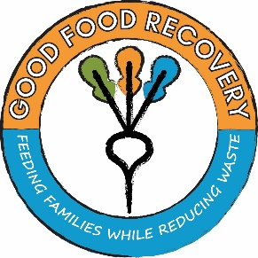

April 2019

Dear Potential Donor,

Good Food Recovery is seeking a tax-deductible contribution for our Grow A Row project. A donation would be utilized to help supply healthy food to people in your community.

Donations sought include, but not limited to, packets of seeds to be used by community gardens and urban farms or a monetary donation to purchase seeds and other equipment needed. Also, the project is seeking home gardeners or farmers to grow an extra row of produce to be donated to Good Food Recovery.

The goal of the Grow A Row project is 1000 packets of seed and 75 rows of produce to be donated. Thank you for your consideration. If you have any questions or concerns, please contact Shanita at 309-929-0308 or goodfoodrecovery@tchd.net. For further information regarding Good Food Recovery, please visit www.tazewellhealth.org.

Sincerely,

Shanita Wallace

Name__________________________________________________________________________________________

Address ________________________________________________________________________________________

City, State ________________________________________________________ Zip Code ______________________

Phone _________________________________________ Email ___________________________________________

❍ Enclosed donation of:
# of packets of seeds: _________
# of rows grown for donation: _________
Monetary donation of $________
Please make checks payable to: Tazewell County Health Department • All donations tax deductible.
Mail to Good Food Recovery, 21306 Illinois Route 9, Tremont, IL 61568

